

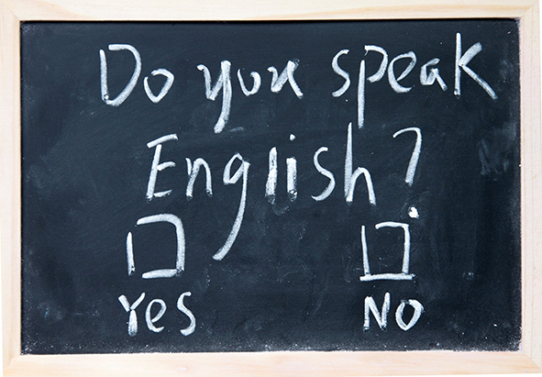

TEST YOUR ENGLISH

Tom __ English.
are
am
is
be

__ there a restaurant near here?
Are
Have
Do
Is

I didn't __ TV last night.
not watched
watch
watching
watched

Look! The bus __.
leaves
leaving
does leave
is leaving

I've never __ to England.
been
went
going
go

__ to go out to an Italian restaurant tonight?
Do you like
Are you liking
You like
Would you like

To get to the Post Office, __ at the end of this road.
go along
go over
turn right
go past

Excuse me, __ time please?
you have the
what is
have you got the
what

Dubai has __ building in the world.
bigger
the most tall
the tallest
tall

I think I've got a cold, I can't stop __.
sneeze
sneezing
to sneeze
the sneezing

My parents __ married since 1985.
got
were
have been
are

Hurry up or we'll __ our train!
lose
fail
catch
miss

You're from New York, __?
isn't it
aren't you
don't you
you are

I don't know many people __ still smoke nowadays.
they
who
which
what

My mother __ me to buy some tea.
told
said
spoke to
told to

I wish I __ get up early every morning!
didn't have to
mustn't
hadn't
wouldn't have to

You should __ my advice!
listen
hear
do
take

How much time do you spend __ English?
study
studying
to study
studied

You should __ for directions if you're lost.
asked
asking
to ask
ask

Are you going to the cafe? __ with you.
I'll come
I come
I can be coming
I'm come

A lot of products __ in China.
are made
made
are making
is made

What is this __ in English? I can't remember.
called
said
named
spoken

If I __ earlier, I wouldn't have been late for work.
left
was leaving
had left
have left

By 2020 I think we will __ a settlement on Mars.
have built
have been building
be built
built

There were __ of people at the football match on Friday.
great deal
fives
many
hundreds

Do you fancy __ away for the weekend?
go
to go
going
be going

__ to bring your passport. You'll need it at the airport.
If I were you I'd
You should
Don't forget
You'd better

Mark: I've had a headache for three days.
Sue: __ to the doctors.
You should
If I were you I'd go
Try go
You must

There are so many people off sick we'll have to put the meeting __ until next week.
back
off
over
by

Where's your car today? It __ repaired.
been
was
is being
was being

If the people on the ship __ him, he would have drowned.
had seen
hadn't seen
could see
saw

The journey __ much longer than I had expected.
is taking
took
was taken
had taken

He didn't enjoy studying abroad as he had __ friends there.
little
a few
few
a lot of

There's __ in applying for the job. I'm not qualified for it.
no reason
no point
no worth
no chance

Please remain seated __ the plane has come to a complete standstill.
as
while
until
as soon as

It's __ to go climbing alone.
danger
risky
hazard
threatening

Chen's looking forward __ his new job next week.
to starting
to start
starting
in starting

It's almost midnight. He __ be coming now!
can't
mustn't
mightn't
can

The car __ start this morning, so I was late for work.
couldn't
shouldn't
wouldn't
hadn't

You __ be really excited about your trip to Germany.
could
must
have to
ought

It looks __ it's going to rain.
alike
as like
as
as if

The new GPS is __. I don't know how we managed without it before.
priceless
worthy
invaluable
valueless

I wish I __ more at college. I'd have a better job now!
studied
had been studying
had studied
would have studied

I was __ when I heard I'd got the job.
pleased
pleasing
excitable
exciting

My manager __ on excellent punctuality at all times.
advises
demands
persists
insists

We have been __ that a new training centre should be built.
advise
advised
adviced
advising

It's important that everyone in the group __ each other.
goes along
gets on with
gets along
goes on with

Pablo denied __ the money.
having took
to have taken
having taken
had taken

There were __ of people at the football match on Friday.
a great deal
a large amount
many
hundreds

There is __ traffic in Bangkok.
plenty of
a lot
too much
too many

